Rahma Abdel-Aty Hassan Mohamed Alwaleed

***Graduated conversation department***

***Qena, Faculty of archaeology, South Valley University E_mail:*** [*rahma.abdelati@arch.svu.edu.eg*](mailto:rahma.abdelati@arch.svu.edu.eg.com)

# PERSONAL INFORMATION

**Position Nationality Birth Date Religion Marital Status Address**

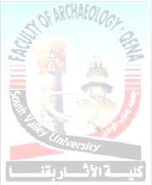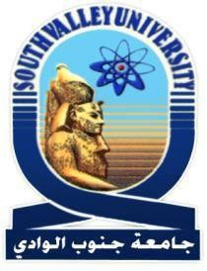

**Telephone numbers**

**Work Mobile FAX**

**E_mail**

**Graduation project:**

**Graduated Egyptian 1/8/1996**

**Muslim. Single**

**Conversation Department, Qena faculty of *archaeology***

**South Valley University**

**096/ 3366850**

**01023050269**

**096/ 5211279**

[**rahma.abdelati@arch.svu.edu.eg**](mailto:rahma.abdelati@arch.svu.edu.eg%20%20)

The role of nanoparticles in reducing the bio-deterioration on well building

**Curriculum vitae of**

**Rahma Abdel Aty H.M. Alwaleed**

# EDUCATION AND CERTIFICATION:

BACHELOR (B.SC.)

**University Faculty Department Grade Graduation Grade**

**South Valley University. Faculty of Archaeology. Conversation Department Good, July 2018.**

**Good (72.3%)**

**Curriculum vitae of**

**Rahma Abdel Aty H.M. Alwaleed**



**2**



# EXPERIENCE, TRAINING AND SKILLS:

EXPERIENCE & TRAINING:

- Training Course in ethics and professional ethics, Development Center, faculty members and leaders, South Valley University.

* Training Course in quality standards in the educational process, Development Center, faculty members and leaders, South Valley University.
* Training course on E-Content- Information &Communication Technology (ICTC- Trainng), South Valley University.
* Training Course on AutoCad principles &Applications in Archaeology

-

**Curriculum vitae of**

**Rahma Abdel Aty H.M. Alwaleed**



SKILLS

COMPUTER SKILLS:

* + Get the ( IC3 ) International Computer Driving License.
  + Good knowledge of using Microsoft office.
  + Good ability to explore the Internet and how to deal with it.
  + Good knowledge Word Processing.
  + Good knowledge of Advanced Power Point.

-. Good knowledge of Photoshop

-.passed the examinations of AutoCAD -

LANGUAGE SKILLS:

* Arabic: Native.
* English: fluently in both speaking and writing and reading listening English.

PERSONAL SKILLS

- Ability to plan, organize and implement different group activities.

- Team player with strong leadership, communication & innovation.

- Extremely organized person.

- Ability to learn when and wherever found.

- Ability to live and/or serve in hardship locations

* Have a good representation & communication skills.
* Very good ability of communicate with people at all level.

**I declare that all the above information is true**

## Thanks for attention*.*

**REFERENCES**

## Available Upon Request

**Curriculum vitae of Rahma Abdel Aty H . M . Alwaleed**



